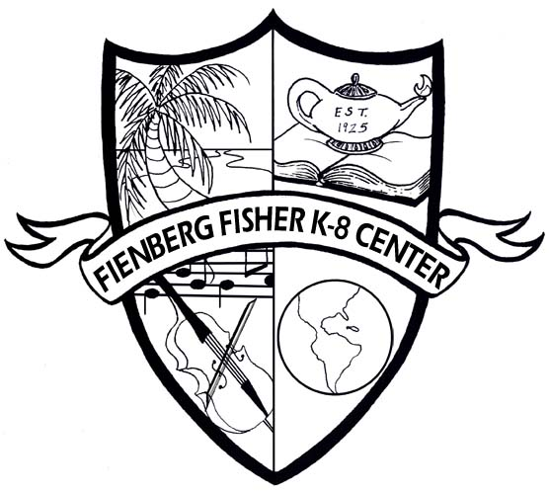 Fienberg-Fisher K-8 Center
IB Candidate School

BUY A BRICK PROGRAM
We are raising money to rebuild our playground.
Yes, we’d like to reserve a permanent brick. Please engrave our brick as follows:

ANY SYMBOL IS CONSIDERED ONE SPACE (PERIOD, COMMA, DASH)
ALL TEXT IS CENTERED UNLESS OTHERWISE NOTED
4 x 8 Brick for $50.00

8 x 8 Brick for $75.00

EXAMPLE
F | I | E | N | B | E | R | G | - | F | I | S | H | E | R |  | P | T | S | A
 |  |  |  |  |  |  |  | 2 | 0 | 1 | 1

PLEASE RETURN THIS FORM AND YOUR CHECK PAYABLE TO:

Fienberg-Fisher K-8 Center PTA
1420 Washington Avenue
Miami Beach, FL 33139
Name: ________________________________________ Phone: (_______) _________________________
Address: _______________________________________________________________________________
City: ____________________________________ State: __________________ Zip: __________________
Email Address: ___________________________________________ Amount Paid: ___________________

.
If you have any questions, please call Ms. Khatmor at (305) 531-0419 or e-mail mkhatmor@dadeschools.net

